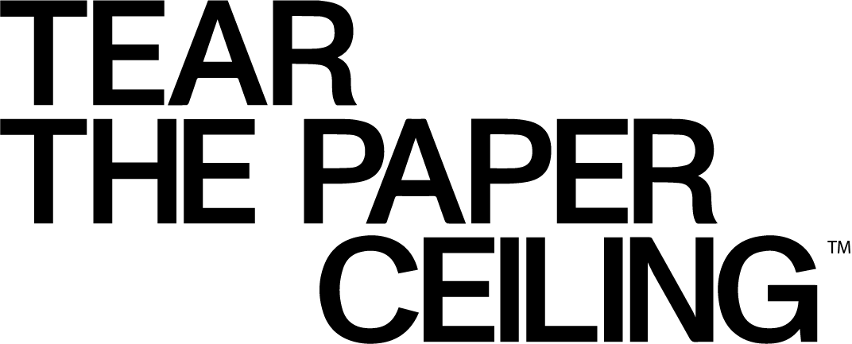

SAMPLE PSA DIRECTOR LETTER

Your corporate logo/header

Date
Name
Title
Station/Media Name
Street Address
City, State, Zip Code

Dear (Personalize for each Public Service Director):

I’m reaching out to tell you about the new Transforming Hiring & Diversifying Talent – Tear the Paper Ceiling PSA campaign from the Ad Council. Transforming Hiring & Diversifying Talent – Tear the Paper Ceiling is an integrated, multi-year communications campaign with the goal of championing skills-based hiring. Millions of workers with in-demand skills are being overlooked, undervalued, and filtered out before even being considered. We call these 70 million workers STARs: workers Skilled Through Alternative Routes. STARs make up 50% of the U.S. workforce and have developed valuable skills through community college, workforce training, bootcamps, certificate programs, military service, or on-the-job learning, rather than through a bachelor’s degree.

STARs face a “paper ceiling” – the invisible barrier that comes at every turn for workers without a bachelor’s degree. Lack of alumni networks, biased algorithms, degree screens, stereotypes, and misperceptions all contribute to the paper ceiling, creating barriers to upward economic mobility for STARs, even though they have demonstrated skills for higher-wage work.

The PSAs are designed to reach both Employers and STARs, encouraging them to tear the paper ceiling and shatter the myth that no bachelor’s degree means no skill. PSAs drive to TearThePaperCeiling.org, where STARs can find resources to help them break through barriers, and Employers can find out how STARs can meet their talent needs.

We ask you to help support the campaign by airing the PSAs that you received. Additionally, the campaign materials can be downloaded from the Ad Council’s website. The campaign materials include TV, radio, digital media, outdoor and print, all of which direct to TearThePaperCeiling.org. By airing the PSAs, you are helping us increase awareness, educate, and ultimately create a new and more equitable future of work. Thank you for your time and support!

Sincerely,
Name
Title
Company/Organization

